**Introduction:**

The documentation deals with the analysis of requirements of the system and differentiated in terms of functional and non-functional requirements. This is then prioritized using MoSCoW prioritization method.

It also encompasses several models to describe and manifest how the system looks like and how it functions. This includes use-case diagram, initial class diagram, and ER diagram followed by UI design.

**Functional and Non-Functional Requirements:**

Functional requirements states what the system should door provide for users. It includes description of the required functions and details of data to be held in the system. E.g. business rules, administrative functions, authentication, adjustment and cancellation, certification requirements, etc.

Non-Functional requirements states how the system performs a certain function. It specifies the system quality attributes or characteristics. E.g. scalability, capacity, availability, usability, etc.

.

**Requirement Analysis:**

|  |  |  |  |
| --- | --- | --- | --- |
| **S. No** | **Requirements** | **Functional or Non-Functional** | **MoSCoW** |
|  | Registration | F | M |
|  | Login | F | M |
|  | Search and select items | F | M |
|  | Order items | F | M |
|  | Retrieve bill | F | M |
|  | Rate and review items | F | C |
|  | Post queries | F | S |
|  | Post comment | F | S |
|  | Delete posts | F | C |
|  | Update account details | F | S |
|  | Add items | F | M |
|  | Update item details | F | M |
|  | Delete items | F | M |
|  | Control user account | F | C |
|  | Create bill | F | S |
|  | Retrieve sales record | F | S |
|  | Generate Bill | F | S |
|  | Logout | F | M |
|  | Visitor counter | F | C |
|  | Authentication | F | M |
|  | Security | NF | S |
|  | Performance | NF | S |
|  | Availability | NF | S |
|  | Reliability | NF | S |
|  | Maintainability | NF | S |
|  | Usability | NF | S |
|  | Data Integrity | NF | S |
|  | Supportability | NF | S |

**Use Case Diagram:**

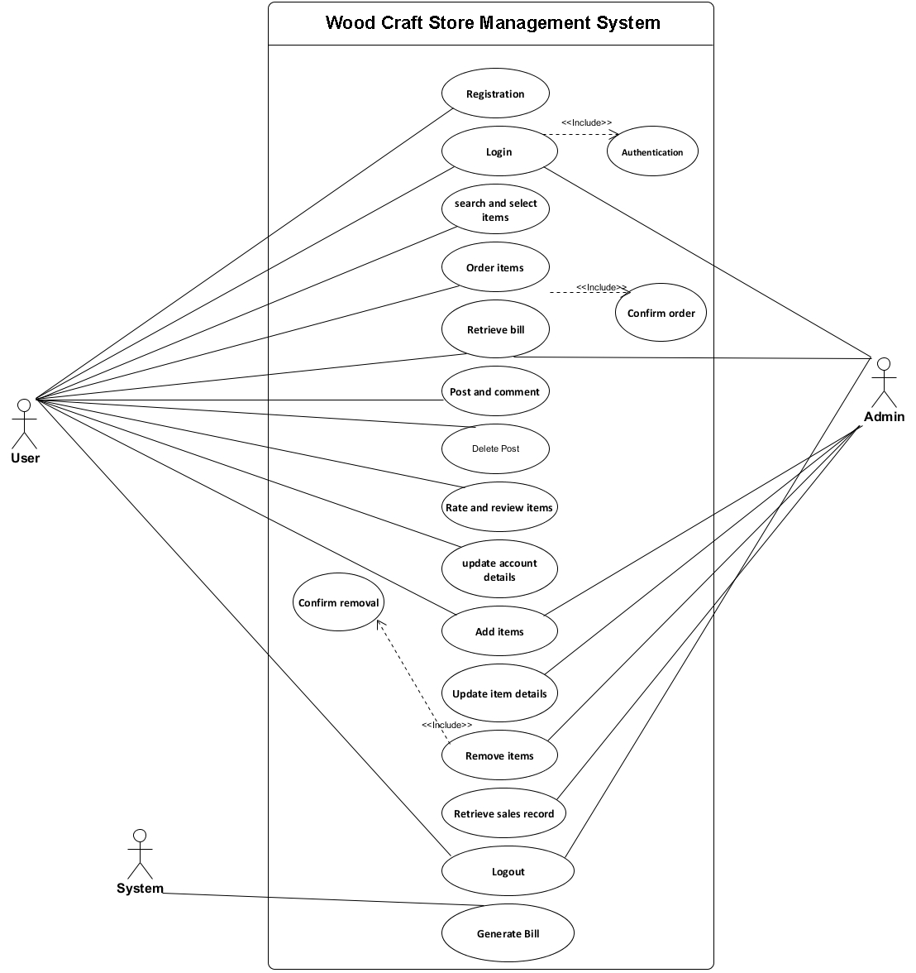

**Initial Class Diagram:**

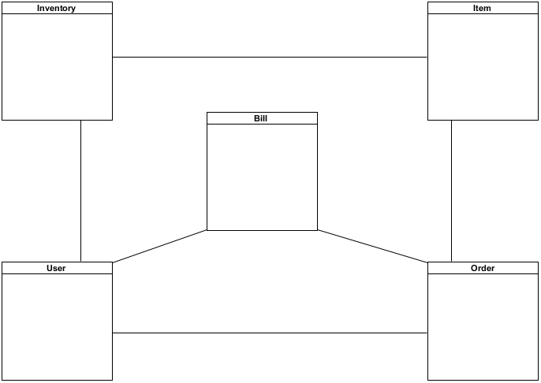

**ER Diagram:**

